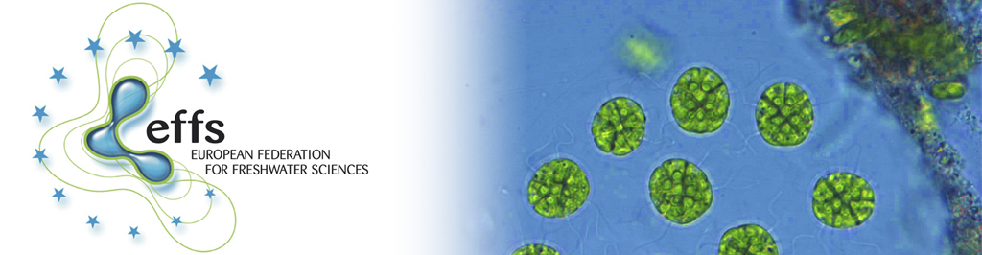

Call to join the 2nd European FreshProject “Urban algae”
Dear colleagues,

We are very pleased to inform you that Urban algae was selected the 2nd Collaborative European Freshwater Science Project for Young Researchers ("FreshProject"), a joint initiative by the European Federation of Freshwater Sciences (EFFS) board, the European Fresh and Young Researchers (EFYR) and representatives of the Fresh Blood for Fresh Water (FBFW) meetings.

We are now looking for young freshwater scientists (with both natural and social backgrounds) to form teams (minimum two persons) and to join our Europe-wide study. The objective of this study is to assess the ecological status of urban ponds and their ecosystem services together with the citizen´s perceptions.

Interested young researchers can find more information in the attachment [see PDF attachment]. In order to participate in the project, please fill in the online questionnaire [here]. The application is open until April 23rd, midnight GMT, 2018.

We are also open to external collaborations through the Urban algae network. Please contact us with your ideas!

Please forward this call and the questionnaire to any of your colleagues who might be interested.

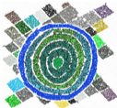
Fresh regards,
the Urban algae team

Sonia Herrero (herrero@igb-berlin.de)
Cleo Stratmann (c.stratmann@nioo.knaw.nl)
Susanne Stephan (s.stephan@igb-berlin.de)
Mandy Velthuis (m.velthuis@nioo.knaw.nl)
Or: urbanalgae@outlook.com

